| Accent icon | Meeting Minutes |
| --- | --- |

# Call to order

A scrum meeting of 1st **sprint review** was held at **google-meet** on **14/10/2020.**

# Attendees

Attendees included **Sediqa Safa, Zahra Karimi, Abdul Matloob Ahmad, and Shahim Nadery as members of development team, Ali Reza Mohammadi as the product owner, and myself Humaira Farewar as scrum master of the project. (The meeting was between scrum master and the development team)**

# Members not in attendance

Members not in attendance included **none.**

# Reports

In this meeting I (the scrum master) and the members of the development team reviewed the project at hand to see if the tasks given for the 1st sprint are finished in the presence of the Ali Reza (the product owner).

# 1st sprint backlog

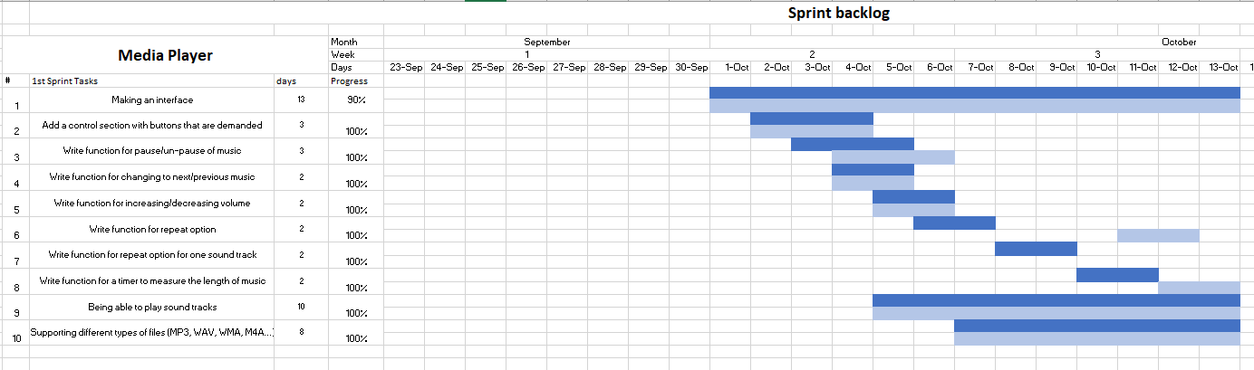

# Burn out chart

Estimated hour to work on each task per day was 1 hour.





      
      
      
      